

Curriculum Policy



Thomas Keaney, CEO and Schools’ Proprietor

Date of next formal review, September 2020

This policy applies to all The Complete Education Solution
(TCES) schools and services

Contents
Introduction to the TCES Group Curriculum 3
TCES Group Schools’ Community Values 3
TCES Group 5-Part Curriculum 3
Academic Including Vocational Curriculum 4
Therapeutic Milieu 6
Enrichment Curriculum 6
Engagement Curriculum 6
ASC/SEMH Specific 7
The TCES Group Curriculum Guarantee 7
The Arts Week 7
Cultural week 8
L.I.F.E. programme 8

Introduction to the TCES Group Curriculum

At all TCES Group schools we value and support learning; instilling pride in ourselves, our school and our community and recognising the worth of each individual. Our mission is to ensure pupils acquire knowledge, skills and abilities that will enrich their lives and enhance their ability to contribute to the community by engaging in a meaningful educational experience, appropriate to each pupil.

One of the principles underlying the TCES Group curriculum is the belief that pupils' self-esteem, confidence and emotional stability can be greatly improved through academic achievement. TCES Group schools endeavour to provide a broad and balanced curriculum. In addition to the core subjects, we provide a range of subjects, which are of particular interest or relevance to the pupils as well as our unique L.I.F.E. programme (Leadership, Independence skills, Financial awareness and Empowerment, Employment and Enterprise skills).

The curriculum has been developed and implemented in line with the Independent School Standards (2014) and is closely aligned to the National Curriculum.

The range of subjects available in the TCES Group curriculum helps pupils “acquire knowledge, understanding and skills in all aspects of their education, including the humanities and linguistic, mathematical, scientific, technical, social, physical and artistic learning” as required by The Common Inspection Framework (2018).

TCES Group Schools’ Community Values
The TCES Group CEO and Schools' Proprietor’s personal vision sees our schools as inclusive, thriving, socially and emotionally healthy communities - this vision is driven by his deeply held belief that human beings thrive in positive environments.

To enable this to happen TCES Group staff and pupils must be supported to own and deliver the community values of our schools and services, which are;

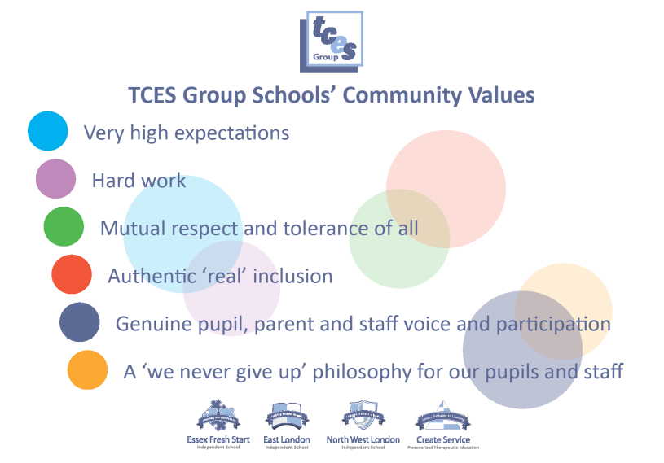

TCES Group 5-Part Curriculum

Our curriculum has undergone significant development and offers additional opportunities for pupils to succeed. Most pupils hold Statements of Special Educational Needs or Education Health and Care Plans, many of which specify a broad and balanced curriculum. Therefore the curriculum has two primary foci: to tackle the behavioural, emotional and social difficulties of the pupils and to redress any academic underperformance.

The planning of the curriculum also has a strong focus on practical activities, which improve relationships with peers and adults, encourage collaborative and team working and enhance confidence, motivation and pupils' self-esteem. This will assist pupils to become fully engaged in the curriculum using stimulating, age appropriate materials in which personal interests and strengths are developed through projects and attainable goals.

Differentiation is vital to ensure that all pupils can access the curriculum to the level that is currently appropriate for them specifically. This is delivered through guided subject choices, tailored curriculum resources and lesson planning to match the individual needs of every pupil within a class group. Individualised timetables are also available in a variety of different formats to meet pupils’ differing needs.

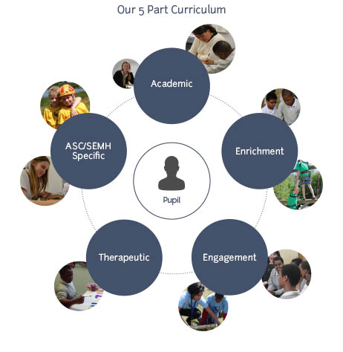

Academic Including Vocational Curriculum
We have very high expectations of our pupils and as such our schools and services offer a wide range of nationally accredited courses including A-Levels, GCSEs, BTEC, Entry Levels, and Functional Skills in Literacy and Numeracy, AQA awards, ASDAN, City and Guilds, Princes Trust, Food Hygiene, and First Aid.

Our School will give experience in the following areas:
- Linguistic: this area is concerned with developing pupils’ communication skills and increasing their command of language through listening, speaking, reading and writing. There must be lessons in written and spoken English.

- Mathematical: this area helps pupils to make calculations, to understand and appreciate relationships and patterns in number and space and to develop their capacity to think logically and express themselves clearly. Their knowledge and understanding of mathematics should be developed in a variety of ways, including practical activity, exploration and discussion.

- Scientific: this area is concerned with increasing pupils’ knowledge and understanding of nature, materials and forces and with developing the skills associated with science as a process of enquiry: for example, observing, forming hypotheses, conducting experiments and recording their findings.

- Technological: Technological skills, can include the use of information and communication technology (ICT); developing, planning and communicating ideas; working with tools, equipment, materials and components to produce good quality products; and evaluating processes and products.

- Human and social: this area is concerned with people and with their environment and how human action, now and in the past, has influenced events and conditions. The subjects of history and geography make a strong contribution to this area through the use of IPC (International Primary Curriculum) and IMYC (International Middle Years Curriculum) as well as Cultural week.

- Physical: this area aims to develop the pupils’ physical control and co-ordination as well as their tactical skills and imaginative responses, and to help them to evaluate and improve their performance. Pupils should also acquire knowledge and understanding of the basic principles of fitness, health and well-being.

- Aesthetic and creative: this area is concerned with the processes of making, composing and inventing. There are aesthetic and creative aspects of all subjects, but some make a particularly strong contribution including art, music, dance, drama and the study of literature because they call for personal, imaginative, and often practical responses.

- Vocational: this gives pupils direct training and learning of subjects of a more practical nature.

Therapeutic Milieu
We underpin our academic offer with a wide range of therapeutic interventions including speech and language therapy, occupational therapy, Group Process, Relationship mentoring, Leadership and Life Skills coaching and focused tutor time.

Whilst some pupils will require individual therapy sessions, the therapeutic offer aims to move all pupils from social isolation to inter-dependence and onto independence and this is achieved by moving pupils into groups, whether that be class groups, social groups or therapy groups, at the earliest opportunity.

Enrichment Curriculum
Our pupils benefit from participating in a variety of activities designed to enrich and enhance their educational experience. Our enrichment Curriculum is intrinsically linked to elements of social, moral, spiritual and cultural (SMSC) education and British values. The added element of our enrichment curriculum is the aim to nurture the often hidden talents of each pupil. The enrichment curriculum responds to the interests and aspirations expressed by our pupils and includes charitable endeavors and community based service.

Some examples of the Enrichment curriculum which allow pupils to increase their awareness and understanding of their environment, development and of the world and its diversity include:
- Trips to museums
- Trips to galleries
- Studying various different places of worship
- Visiting local places of interest and studying national places of interest
- Daily reading programmes (D.E.A.R.)
- Horse-riding and equestrian care
- Fire Break (London Fire Service course)
- Prison Me No Way

Engagement Curriculum
Although a significant percentage of our referred pupils join our schools directly after a short internal induction, some of our pupils may require individualised support to enable them to flourish in full time education. This engagement support is delivered through our school teams internally.

- For the truly disengaged learner a more personalised approach to the curriculum is offered incorporating intensive one to one support to help each pupil break down barriers, develop basic skills and support transition into group learning.

- The TCES Group Attendance toolkit drives every school’s consistent focus on improving attendance. Attendance focus plans are introduced where there is cause for concern and strategies introduced such as daily phone calls home, weekly vouchers for 100% attendance as well as awards presented at the school’s annual prize giving for ‘highest attendance’ and the Head Teachers Award for the best overall achievement.

ASC/SEMH Specific
By addressing individual needs in relation to a pupil having an ASC or a SEMH diagnosis, we create learning environments and take informed approaches to ensure the development of each pupil’s capacity to learn. The TCES Group curriculum guarantee is offered to all pupils and is adapted to cater to the needs and interests of individual pupils to ensure they are engaged and excited to learn.

The TCES Group Curriculum Guarantee

As Independent Schools, we are not obliged to follow the National Curriculum. However, the TCES Group Curriculum Guarantee follows the National Curriculum as closely as possible, all the while considering our pupils’ difficulties in accessing education and making progress.

The TCES Group Curriculum Guarantee constitutes the curriculum policy and practice as implemented in all TCES Group schools. It is the guaranteed curriculum that we provide to all pupils and works alongside the TCES Group 5-part curriculum. It specifies our commitments to our pupils’ academic (including vocational) education.

The Arts Week
The Arts week has been devised as a way of including the creative subjects into our TCES Group Curriculum.

Many creative activities that could fall into Arts week, as a way of introducing our pupils to the subjects are:
- Dance/Drama – performers in the school production/workshops
- Music – performers in the school production/concert
- Art – Posters/Flyers/Invitations to the school production
- Photography – Pupils to photograph/video school production
- Art exhibition – open day/morning showing off all art produced
- School performance Talent show/X Factor – invite parents/carers/Local Authorities
- Food Technology – baking treats for refreshments to Art exhibition/school production/school dinner for pupils and staff
- Design Technology – prop making for school production/souvenirs/set design
- Trip out for pupils – theatre shows/music concerts/art galleries

Cultural week
Our highly successful Cultural week has been devised as a way of linking cultural learning and appreciation into our TCES Group Curriculum. Cultural Week is for every pupil in every school to get involved with.

Pupils, through the student council, decide on which Culture they want to focus on during this week, and the staff must plan to include elements of History, Geography, Religious Education and possibly Design Technology into that chosen topic.

- A particular Historical Event – pupils could focus on an event from History and look at the Geography, Religion and Historical reporting of the event.
- A Geographical area – pupils could research a particular area/country, and link to key historical events and religious changes throughout the area across time.
- A Historical figure – pupils may wish to learn more about a person of interest throughout History – they can research where that person lived, what religion they followed and the key events throughout their life.
- A particular religion – pupils may choose to focus on a particular religion and they could research the history of the religion and the geographical areas where it is practised.
- Trip out for pupils – trips to a historical site, castle, building, or tips to a place of worship, geographical landmark or place of interest or museum.

L.I.F.E. programme
The L.I.F.E programme (Leadership, Independence Skills, Financial awareness and Empowerment, Employment and Enterprise skills) has been developed to support pupils to thrive in their adult life. Leadership and Life Skills Coaching (LLSC) is available to all pupils through focussed and motivational assemblies, group process and, where needed, individual or small group coaching sessions.

Every pupil follows an accredited Leadership course throughout their time at TCES Group. This starts as early as Key Stage 2, where pupils complete courses such as first aid, playmaker award, food hygiene, and carries on up to Key Stage 5 where Post 16 pupils can complete qualifications such as Level 2 Sports Leadership, Advanced Peer mentoring or basic accountancy. All pupils at all key stages also have the opportunity to gain English Speaking Board qualifications.

The TCES Group independent skills programme is supported, tracked and monitored through a whole-school comprehensive award system, leading to bronze, silver and gold awards as their skills develop.

