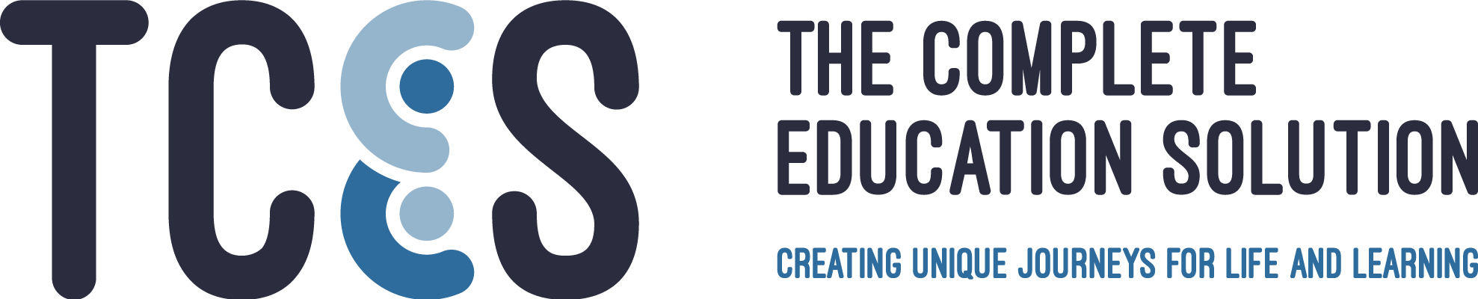

Curriculum Guarantee

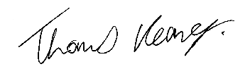
Thomas Keaney, CEO and Schools’ Proprietor

Date of next formal review, September 2021

This policy applies to all The Complete Education Solution
(TCES) schools and services

TCES Curriculum Guarantee

Rationale

This Curriculum Guarantee forms part of the Education Section of The TCES Systems and Processes Manual. It sets out to detail the Curriculum intent for the schools and services; the resources, approaches and opportunities for its implementation and the ways that we will measure, recognize, and celebrate the impact.

This curriculum statement derives from the agreements made amongst the School Support Partnership in the summer of 2020. It constitutes TCES curriculum policy and practice as implemented in all TCES schools. The TCES Curriculum Guarantee is the guaranteed curriculum we will provide to our pupils. It works alongside TCES Five Part curriculum and specifies our commitments to our pupils in Academic (including vocational) education. The SSP set out to provide the broadest possible curriculum offer for all our pupils and with clear and high expectations for achievement and progress. We offer subjects and experiences beyond the national curriculum that are relevant to preparing our young people to enter the world of work and thrive as adults. Time on these subjects slightly curtails the range of traditional subjects we able to offer but does not diminish the breadth of the curriculum.

“A broad curriculum can mean limited subjects.”
Amanda Spielman
June 2020

Our curriculum will, however, give all pupils “experience in linguistic, mathematical, scientific, technological, human and social, physical and aesthetic and creative education;” as required by The Revised Education (Independent School Standards) (England) Regulations January 2015.

Curriculum Intent

Schools Proprietor's vision

As TCES' CEO and Schools' Proprietor, my personal vision sees our schools as inclusive, thriving, socially and emotionally healthy communities - this vision is driven by my deeply held belief that human beings thrive in positive environments. These schools and our social enterprise must lead the way 'Towards a National Model of Excellence'. To enable this to happen TCES staff, parents and pupils must be supported to own and deliver the community values of our schools and services, which are 'very high expectations', 'hard work' and 'mutual respect and tolerance', authentic 'real' inclusion, 'genuine pupil and parent voice and participation' and finally a 'We never give up' philosophy for both pupils and staff.

Our Schools and Services

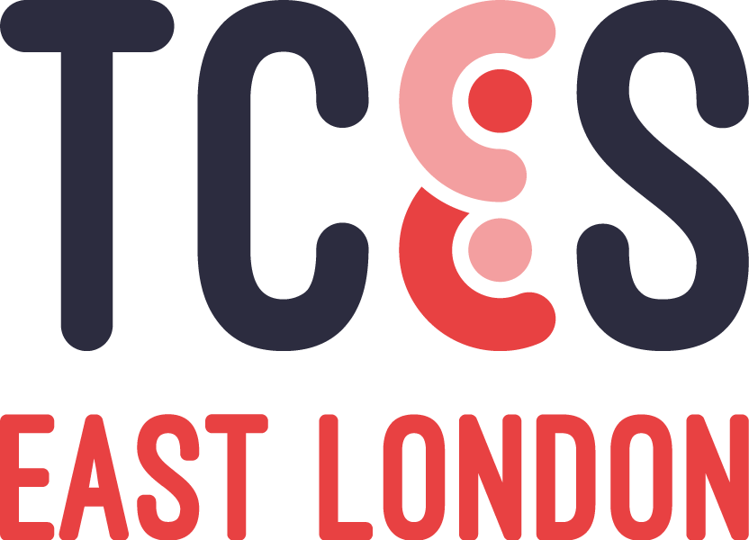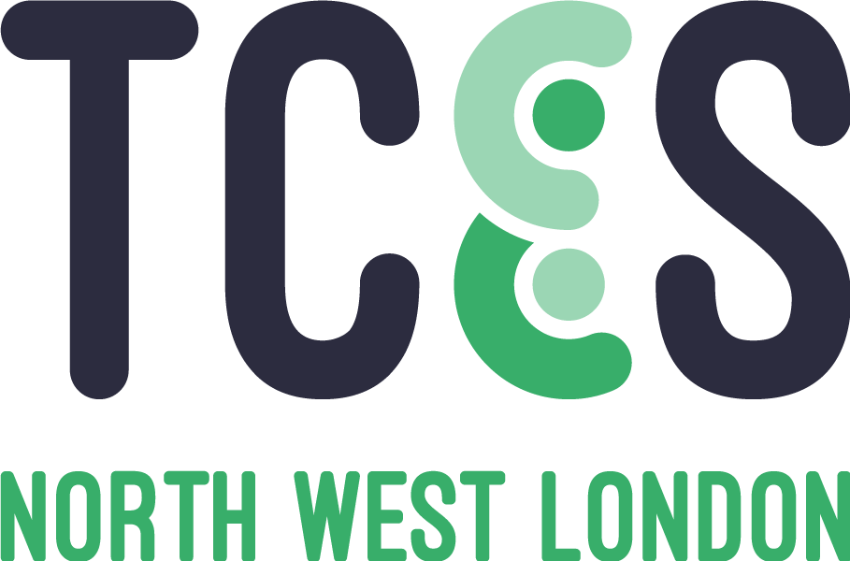

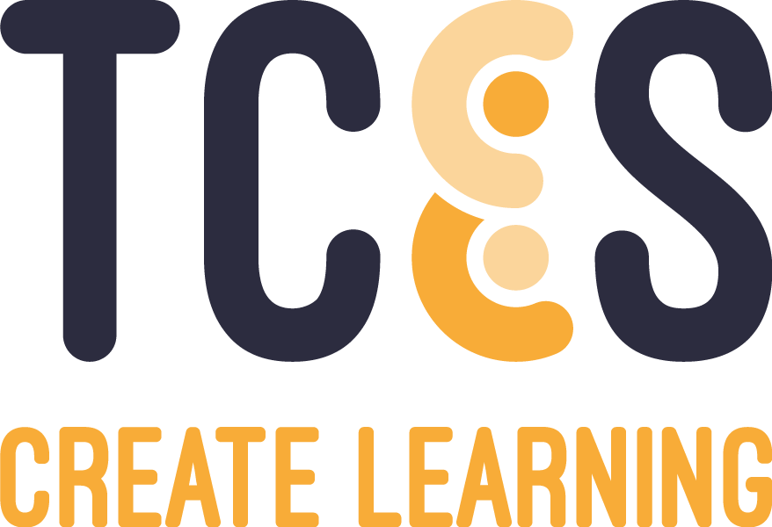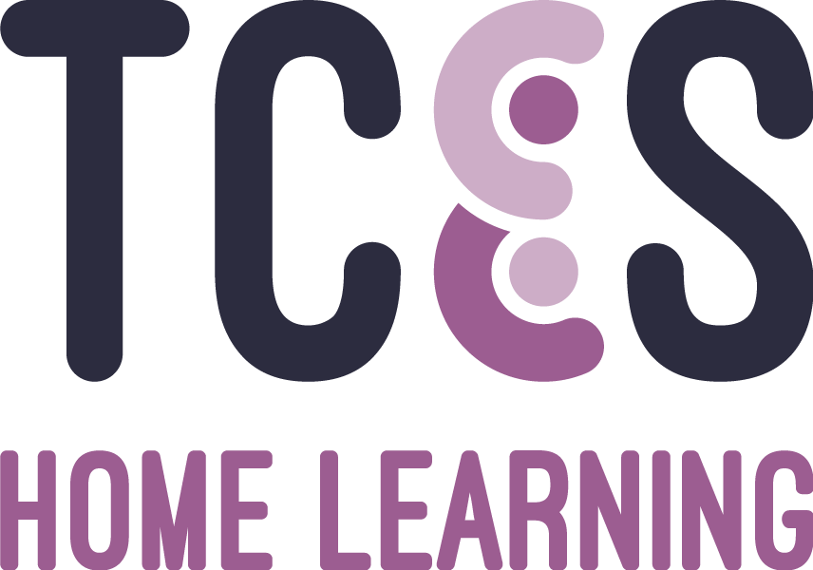

TCES Home Learning

Home Learning offers short-term one-to-one distance or home/community education to children and young people between the ages of 5-19 currently without school-based SEN provision in London. Whether a child or young person is awaiting a placement from a TCES school, another school or service, or is without an integration plan, Home Learning offers immediate support for a child’s educational and personal development.

Home Learning provides a full-curriculum experience and helps pupils to benefit from the same level of academic, therapeutic and wellbeing support as they would in school, providing social interaction opportunities online and through the TCES community.

Home Learning uses stringent measures to vet teachers and follows a comprehensive process to match a pupil’s favoured learning style to the most appropriate teacher for their individual needs. Home Learning operates entirely on a strengths-based approach with pupils so that they can learn and thrive, by providing bespoke resources based on an initial learning assessment that are then implemented effectively. Our highly skilled teachers help transform pupils’ perception of their own strengths and abilities, ultimately preparing them for reintegration to small group learning environments.

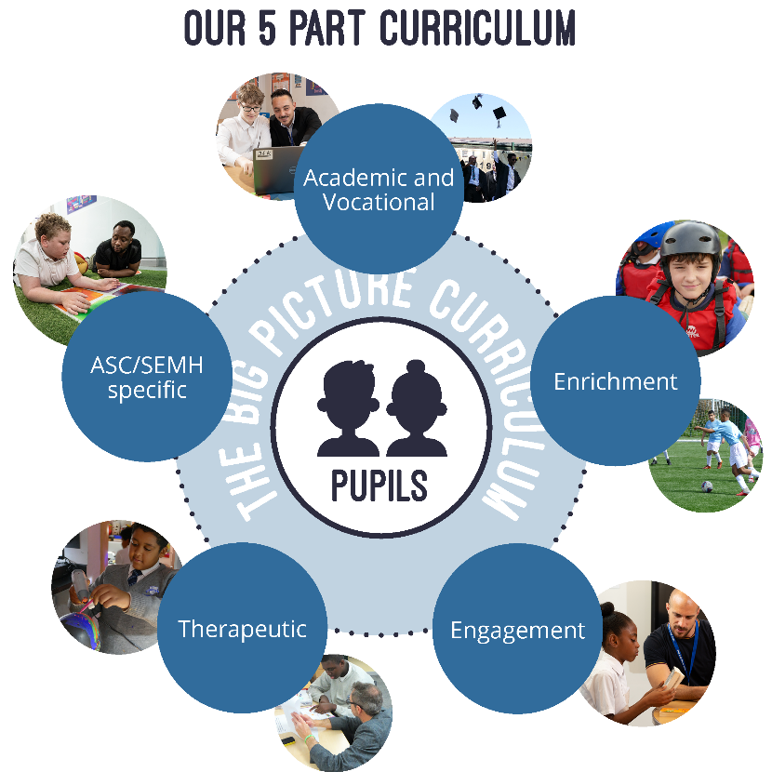
The TCES Five Part Curriculum

Our Five Part Curriculum is designed to meet the educational, therapeutic, social, emotional, and behavioural needs of our school and Create pupils. Our pupils have Special Education Needs and Disabilities (SEND) and whilst diagnosed with SEMH (previously BESD) or ASC, all of our pupils have underlying Speech, Language and Communication Needs (SLCN) in common. Our pupils are not currently able to benefit from being educated within LA Maintained provision.

It is the policy of TCES that all pupils will have access to a broad and balanced curriculum that addresses the difficulties that have caused them to be referred to us.

Our Five Part curriculum assesses and recognises their learning needs and barriers and offers opportunities and experiences that will enable pupils to meet the challenges of adult life. Our curriculum also promotes the TCES values of:

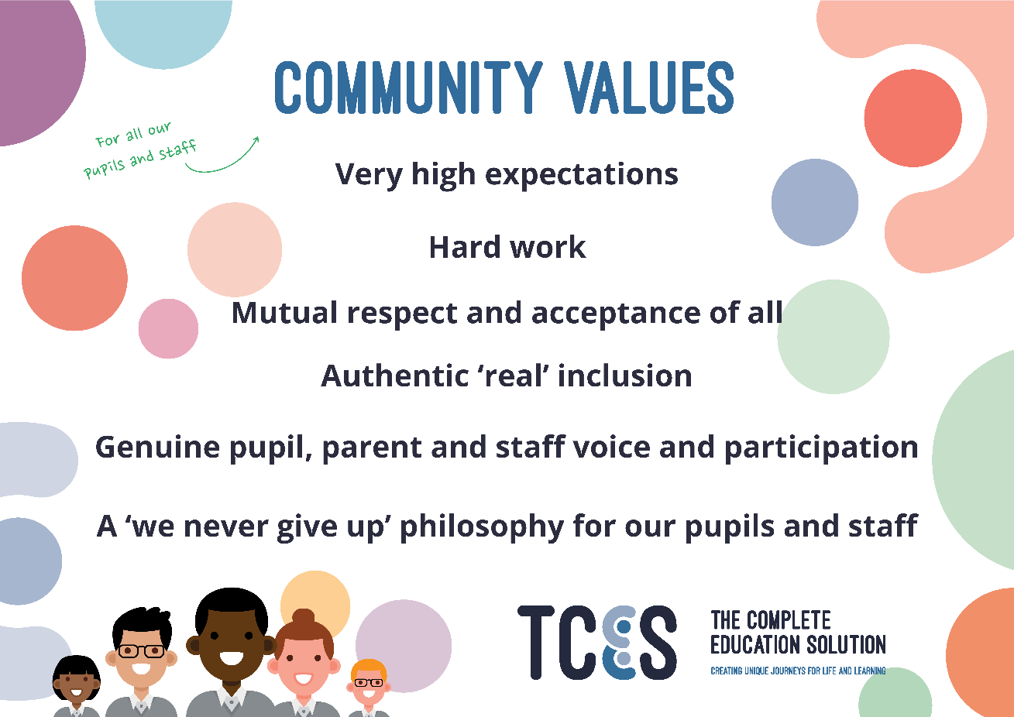

The Curriculum Messages Delivered by the TCES Community Values

We have high expectations of all pupils’ success in every aspect of learning and achievement and firmly believe that expectations shape performance. Our pupils have a broad range of backgrounds and abilities and every single one of us contribute to the personal development, progress, and experience of the pupils in our schools and services. We do this by ensuring that our pupils have a meaningful voice and fully participate in all aspects of the running of our schools and by the example we set not just in lessons but around school or services and in all our dealings with the pupils. It is vital that we treat each other with integrity and respect and are fair and consistent in our approach to everyone in the community. We pride ourselves on the positive relationships that exist in the schools and services and on the creative environment in which we work. We believe that all our pupils have hidden talents that need to be found, nurtured and supported. Our respect, integrity, behaviour, ambition, resilience and humour all form part of the curriculum diet offered to all our pupils.

Everything that we do, along with each decision that we make, must be centred on the pupils’ learning and achievement, as we seek to enable every pupil to meet and exceed their apparent potential. We never give up on a pupil and we have never permanently excluded a pupil. We believe in every pupil’s ability to succeed in our schools and services and our Relational Pedagogical approach ensures the very best of education and clinical input to make this vision a reality.

We are all privileged to be working with the pupils at our schools and services and to have the opportunity to make a significant contribution to their future life choices. Our pupils have an enormous amount of potential and we are all part of an incredibly dedicated and talented staff team who all ensure that we support this potential through to fruition.

We are driven by inclusive practice and understand that our children often fall into a number of the four broad areas of special educational needs. We recognise that if Communication, including Speech and Language, as well as Interaction and Sensory needs are underlying our pupil's original diagnosis' these can be major barriers to learning whether they are SEMH or ASC.

Curriculum Aims

Our curriculum aims to create:
- Successful Learners
  - Who enjoy, make progress, achieve and ‘love to go to school’

- Confident Individuals
  - Who are able to live safe, healthy and fulfilling lives

- Responsible Citizens
  - Who make positive contributions to society

- Independent Adults
  - Who can work with others and be healthily independent when required

Our curriculum will:
- Address disadvantages and disruptions
- Be engaging and enjoyable
- Be broad and balanced and promote community and environmental values
- Be supported by a therapeutic milieu
- Address each pupils’ own level of need and ensure best safeguarding practice
- Enable pupils to negotiate independent pathways from social isolation to independence

Curriculum Composition
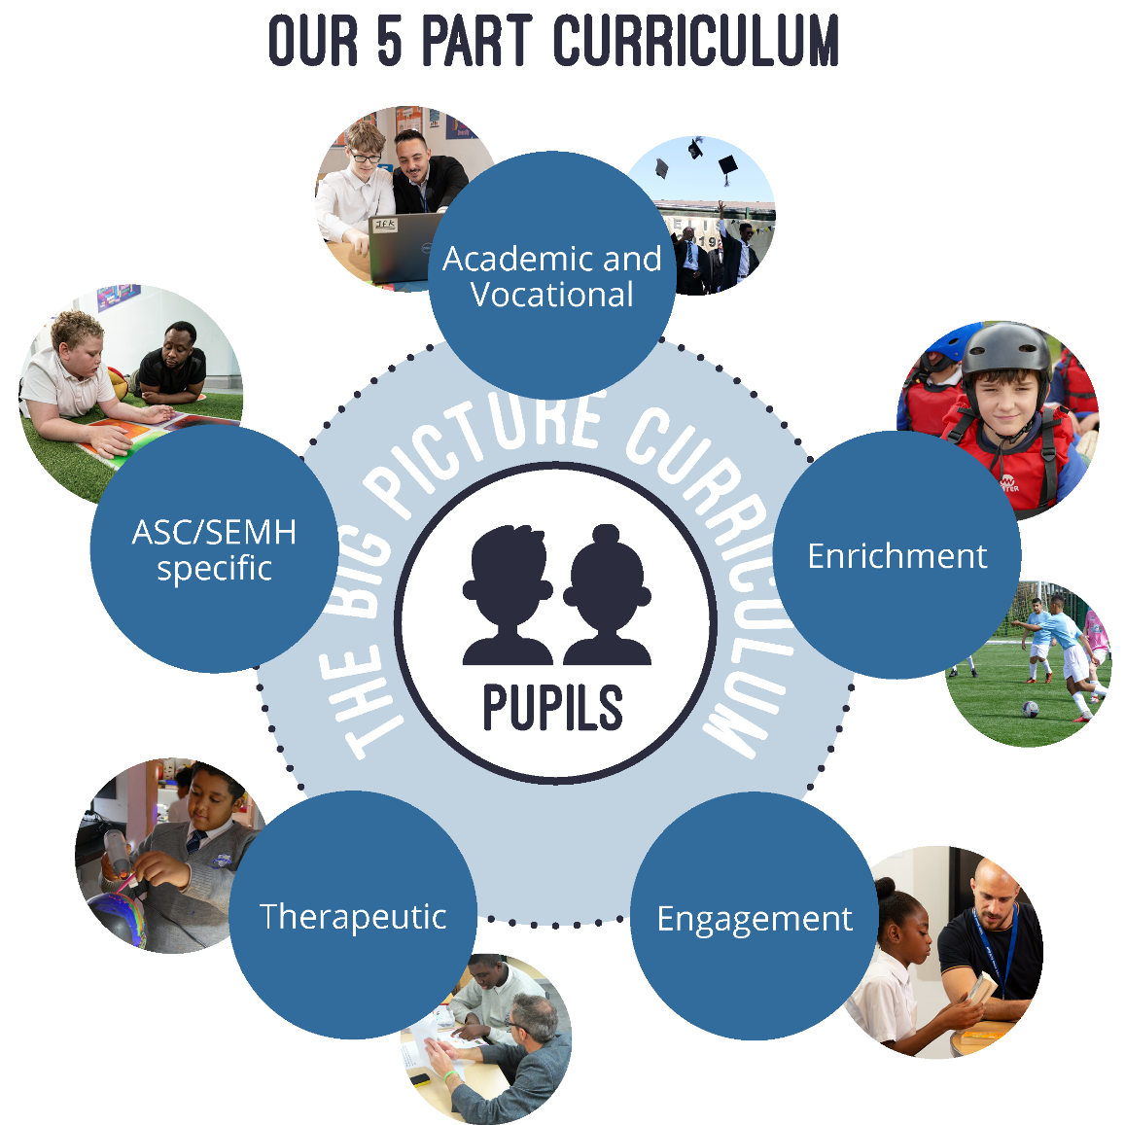
Academic Including Vocational Curriculum

We have very high expectations of our pupils and as such - our schools and services offer a wide range of nationally accredited courses including:
- A Levels; GCSEs
- BTECs
- C&Gs
- Entry Levels
- Functional Skills in Literacy and Numeracy
- English Speaking Board Assessments in Speaking, Debating and Interview Skills
- AQA Awards
- ASDAN Bronze, Silver and Gold Awards
- ASDAN Award / Certificate in Personal Effectiveness Levels 1,2 and 3; and
- Prince’s Trust
As well as a wide range of shorter courses.
For example: Food Hygiene, Food Studies, First Aid, Sports Leadership UK, Virtual College Courses and Driving Theory etc.

Academic and Vocational

Academic and Vocational Curriculum

With the support of a teacher, each pupil creates an Individualised Curriculum Pathway. All pupils then follow courses matched to their ability in English, Maths, Science, Humanities, PSHE, RSE and ICT as well as choosing at least two options from the two Group specialisms: ‘Arts’ and LIFE (Leadership, Independence, Future Options, Employability and Empowerment).

At KS2 non-core subjects are delivered through the thematic styled ‘International Primary Curriculum’ (IPC). The focus then shifts at key stage 3 to working towards nationally recognised qualifications and accreditations.

Enrichment Curriculum

Our pupils benefit from participating in a variety of activities designed to enrich and enhance the school and Create Service experience. Our enrichment curriculum is intrinsically linked to elements of spiritual, moral, social, and cultural (SMSC) education as well as our own Community Values, Community Cohesion, British Values including Britishness, Public Institutions and Every Child Matters.

The added element of our enrichment curriculum is the schools’ and Create Service’s aims to find and nurture these often-hidden talents of each pupil. The enrichment curriculum responds to the interests and aspirations expressed by our pupils including charitable endeavours and community- based service and opportunities for genuine leadership roles within and beyond school. This last element is supported by regular and frequent training of a high standard, often leading to accreditation, such as our Level 2 qualifications for Mentoring, traineeships, and apprenticeships. There enrichment opportunities can lead to career pathways for our pupils to move from entrant to employment within TCES.

Engagement Curriculum

Although a significant percentage of our referred pupils are able to join our schools after a short internal induction, some of our pupils may require individualised support to enable them to flourish in small group full time education. This engagement may present itself in many different fashions all of which are valid in the journey to complete engagement. We recognise that passive, active and stop-start engagement are all methods to facilitate learning. With a whole school approach, a pupil’s learning engagement is understood and utilised to bring them safely and appropriately into group learning. Engagement support is delivered through our school teams internally and may include graduated entry as well as additional one to one support.

In line with our Community Value that we never give up; we never permanently exclude our pupils. Neither do we fixed-term exclude. For those pupils who either need a brief respite from the stresses of group education or who need a re-engagement/refocus programme back into our school services, we provide community or home-based refocus programmes, parallel to our schools, called TCES Create and TCES Home Learning (more detail about these two services in the Implementation section). These services are also used for those in-school pupils who present as either more vulnerable or at higher risk.

Create and Home Learning services are brilliantly versed at supporting pupils with anxiety and other needs. Pupils attending these services are engaged through a very structured Education and Clinical service with an eventual aim that most pupils will be integrated with high levels of support into the Create Therapeutic Education Centres and eventually into or back into our schools. We call this our Step-Down approach leading to integration – from home to community to Therapeutic Education Centre to our schools.

Therapeutic Curriculum

Our academic offer is underpinned by our Relational Pedagogical approach which pervades all that we do in school and is embodied by all staff at every level. We offer a wide range of Therapeutic, Clinical and Inclusion interventions including: Occupational Therapy, Speech and Language Therapy, Art Therapy, Drama Therapy, Nurture Groups, Relationship Mentoring, Leadership and Life Skills Coaching, and Group Process. (Additional therapies including Counselling, Music, Equine therapy etc. are available specifically in our Create services).

The Therapeutic Curriculum is underpinned by a therapeutic milieu with therapeutically informed and trained staff who support the delivery of therapeutic strategies using a milieu therapy approach.

This is achieved through the combined elements of:
- quality therapeutic environments
- forensic understanding of an individual’s needs
- community shared values
- mutual respect and acceptance
- positive peer support
- full pupil and parent voice and participation
- emotionally healthy communities through group work and specialist targeted assemblies on British and Community values.

The therapeutic milieu provides an idealised setting for our pupils as group members to work through their social and emotional needs, supporting them to address their barriers to learning in a healthy and safe manner.

Our Therapeutic Curriculum and provision is available onsite and via online Distance Therapy and is managed, supported, and quality assured by our internal social work, therapists and mental health senior managers.

ASC/SEMH Specific

By supporting and understanding an individual’s ASC or SEMH needs, we create learning environments and take informed approaches to ensure the development of each pupil’s capacity to learn. Although we offer core subjects within each of our schools, Create and Home Learning services, we are also able to adapt our curriculum to cater to the needs and interests of our pupils to ensure they are engaged and excited to learn. Language adapted environments as well as sensory appropriate environments are pre-requisites to an ASC and SEMH specific curriculum.

Our Curriculum: The Big Picture

The Big Picture is the result of an effort by TCES to capture in one diagram: what we are trying to achieve with our curriculum offer (intent), how we will set out to achieve that (implementation) and what measures we will use to judge its success (impact).

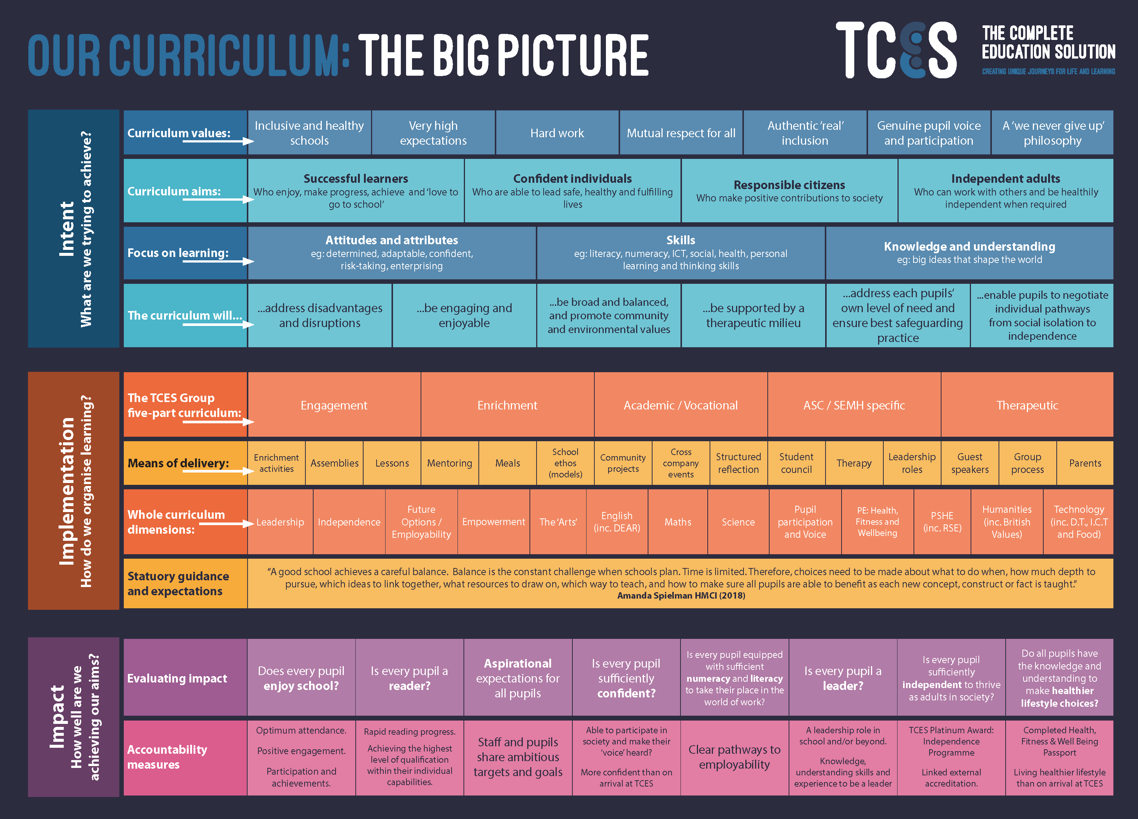
Returning to School Post Pandemic

Transition Curriculum Rationale

During the Coronavirus Pandemic between March and July 2020, TCES pupils attended our schools and services via our Distance Learning Programme. This involved a combination of hard copy resources and virtual learning through Microsoft Teams with pupils following a daily timetable including PE and Wellbeing, English, Mathematics, Creative Arts, and the Independence Skills Challenge (as part of the LIFE Programme).

Using advice from the DfE, Ofsted, NAHT and other professional bodies, as well as internally from our TCES Therapy and Education teams, TCES has developed a Transition Curriculum to restore the ‘mental wealth’ of our pupils whilst meeting the emotional, social, mental, physical and academic needs that have occurred as a result of the Pandemic.

In his presentation on The Recovery Curriculum on 14th July 2020, Professor Barry Carpenter describes the five losses all pupils have faced during the Pandemic:

‘Those 5 losses, of routine, structure, friendship, opportunity and freedom, can trigger the emergence emotionally of anxiety, trauma and bereavement in any child. The overall impact cannot be underestimated. It will cause a rapid erosion of the mental health state in our children.’

Carpenter’s Recovery Curriculum has been an essential construct for the thinking and planning of our Transition Curriculum. Whilst Carpenter describes the mental state of all children, we know that our pupils, given their complex and co-morbid needs, will need even more support after such an extended absence. Therefore, this curriculum has been filled with the content we believe is best for the pupils in our school community and is informed by our inherent understanding of these pupils. Given their complex needs, all of our pupils will need a holistic recovery. Some may need a focused recovery intervention programme, personalised to their needs; others may need a deeper and longer lasting recovery period, enabling a fuller exploration of the severity of their trauma and emergent attachment issues.

The purpose of the Transition Curriculum is to address Carpenter’s 5 levers:

In response to the weight of loss our young people will have experienced during the Pandemic, the Transition Curriculum is built on the 5 Levers, as a systematic, relationships-based approach to reigniting the flame of learning in each of our pupils.
The Transition Curriculum will focus not only on the recovery of lost knowledge but will provide experiences that support the space for recovery. We have recognised that the curriculum has been based in the community for an extended period of time and that our staff will listen to what has happened in this time, understand the needs of our community and journey with each pupil through a process of re-engagement, which leads them back to their rightful status as fully engaged, authentic learners.

Implementation

The TCES Transition Curriculum [Term 1/6]

After much research throughout the summer term in 2020, the whole company devised a Transition Curriculum to successfully reintegrate school-based pupils back to full time, onsite education.

In their Guidance for Full Opening published online in July 2020, the DfE agreed that
‘substantial modification to the curriculum may be needed at the start of the year, so teaching time will be prioritised to address significant gaps in pupils’ knowledge with the aim of returning to the school’s normal curriculum content by no later than summer term 2021.’
Our specialised Transition Curriculum runs for six weeks (term 1/6) and will support pupils to engage with the process of ‘learning to learn again’ (Prof. Barry Carpenter) whilst guiding pupils into the new normality of school life after an extended absence. It echoes Amanda Spielman’s view of a ‘rebuilding’ autumn term and will be ‘Catch Up’ focused to ensure no pupil is disadvantaged.

The Transition Curriculum will include:

Catch Up Programme

All of our schools and services will work to understand and address the gaps in pupil’s learning during the Transition Curriculum period and will provide support to pupils requiring additional intervention. Our schools and services will identify individuals and the required interventions needed and will put a programme of support in place with clear targets and goals. These additional interventions sessions will be devised, based on need, from a range of onsite and online resources including, but not limited to:
- 1-1 support onsite or online
- Access, onsite or online, to educational platforms such as:
- Literacy – Zaprendo (Phonics), Lexia (Reading) and Bedrock Learning (Vocabulary)
- Mathematics – My Maths

Each pupil’s programme of support will be monitored throughout the process and reviewed at the end of Term 1.

A Cross Curricular Transition Curriculum Approach

The Transition Curriculum is not just intended to deliver learning to those pupils who have returned from being educated through our Distance Learning model or those who have been on site with a reduced peer group – it is specifically designed to support each pupil’s re-engagement with group-based learning and assess the impact of the last few months both on their academic progress and on their well-being. The intention is that the transition curriculum is sufficiently distracting from the shock and change that we have all witnessed recently, to support pupils to re-focus on their interests, their potential and their future.
In order to achieve this, we have adopted a cross-curricular approach to the first 6 weeks of school in September. The timetables will itemise daily sessions for Well-Being, English and Maths, but the remainder of each day will be a fusion of subject content delivered through key projects and enrichment activities. For example, from week one, all pupils will be supported to prepare for their school’s Leadership Week in October. This will require them to work on: speaking & listening; presentations using Office applications on their laptops; writing for specific audiences and for persuasion; budget management; British Values; PSHE; graphic art for posters/fliers etc.; goal-setting; reflection; motivation techniques and identifying strengths in themselves and others, to name just a few.

Throughout this cross-curricular approach, schools will seize the opportunities for pupils to gain externally-validated accreditation, such as in ICT for their presentation work, and through the English Speaking Board accreditation programme, for which we have specifically sought guidance and training when developing this Transition Curriculum.

Catch-up programmes will be in place alongside these projects and we have reviewed many so that we are only using those catch-up programmes that will have the biggest impact for our cohorts of pupils. However, we recognise that a diet of traditional lessons and catch-up sessions will never provide for the deep-rooted needs that must be met for the successful long-term re-engagement of our pupils. We believe a transition curriculum based on relationship-building and project-based learning is more likely to provide the conditions for success.

Methods of Curriculum Delivery

Blended Offer

Our curriculum is designed to be accessible to all pupils attending our schools and services. The Blended Offer ensures inclusion at every level for every pupil and is a combination of onsite and online learning.

We understand that in order to prepare our pupils for further study, the world of work, or indeed another local lockdown, it is imperative that we teach them the skills and behaviours to enable them to participate appropriately and function effectively online and in virtual classrooms.

After signing a Code of Conduct (by pupils and parents/carers) which highlights online safety and promotes the positive use of technology, every TCES pupil receives a laptop, pupil email address and access to the Microsoft Office 360 platform for Education.

Each school and service has a virtual classroom on Microsoft Teams which mirrors their class group, timetable and the curriculum of their onsite provision. Whether school-based or not, all pupils join their virtual classroom, where they can attend and participate in lessons, view resources, submit assignments, receive feedback from staff, and collaborate with peers via Teams.

When arranged in advance, live lessons delivered onsite can be attended virtually through Teams or viewed (at a later stage) on demand by class members who are not able to attend onsite educational provision. This mode of curriculum delivery is particularly useful for pupils preparing to join an onsite class from the Create or Home Learning services. Pupils can meet their teachers and peers virtually, participate in online learning experiences, and feel they are part of the class group long before physically entering the school building.

The Transition Curriculum Through the Blended Offer

Whilst the DfE’s aim is ‘for all pupils to return to school in the autumn term’, every school has been asked to plan for the possibility of a second local lockdown. The Transition Curriculum has been designed to ensure access for all and to ensure the continuity of education for every pupil.

As with the previous TCES Distance Learning curriculum which ran between March and July 2020, the Transition Curriculum’s daily timetabled sessions will be made available live or videoed online via Microsoft Teams by each school or service, complete with appropriate resources, regular opportunities for staff feedback and collaborative peer working.

The TCES Big Picture Curriculum [Terms 2 - 6]

After the 6-week Transition Curriculum we will return to our normal Big Picture Curriculum. As Independent Schools, we are not obliged to follow the National Curriculum. However, at TCES, we are trying to keep our TCES Curriculum as close to the National Curriculum as possible, all the while considering our pupils’ difficulties in accessing education and making progress.

The School Support Partnership has selected 9 key subjects that all schools must include on their timetables from October 2020 to ensure that our pupils are accessing, not only the off-site enrichment activities, but the core curriculum subjects also.
We recommend as a guide, how many lessons each Key Stage will have of education in each of these 9 subjects, based on recommended guided learning hours for the qualifications we deliver. This is shown below:

SUBJECT | KEY STAGE 2 | KEY STAGE 3 | KEY STAGE 4 | KEY STAGE 5
ENGLISH  + DEAR | 5 | 5 | 5 | 5
MATHS | 4 | 4 | 4 | 4
SCIENCE | 2 | 3 | 3 | 3
LIFE Specialism | 2 | 2 | 2 | 2
‘ARTS’ Specialism (min) | 2 | 2 | 2 | 2
TECHNOLOGY | 1 | 1 | 1 | 1
HUMANITIES | 1 | 1 | 1 | 1
PE: HEALTH, FITNESS AND WELLBEING | 2 | 2 | 2 | 0
PSHE (inc. RSHE) | 1 | 1 | 1 | 1
TOTAL | 20 | 20 | 21 | 19
REMAINING SESSIONS  (To include assemblies, Wellbeing sessions, Group Process, Enrichment etc.) | 5 | 3 | 3 | 6
Sessions per week | 25 | 25 | 25 | 25

The remaining hours left after the Core Curriculum subjects have been taught, are to be used for off-site activities, enrichment, relationship mentoring, therapy sessions or other standing subjects a school may be teaching.

TCES Specialisms
Each of the TCES schools and services has two specialisms: LIFE and ‘Arts’. Every pupil has the unique opportunity at TCES to select curriculum pathways that will lead to Level 2 (GCSE or equivalent) qualifications in two specialist areas.

TCES has an extremely strong history of delivering Level 2 and Level 3 outcomes in the ‘Arts’ for our pupils. Recent successes include A levels (including one A*); AS and many GCSEs, ranging from Graphics to Photography and Art & Design. This year all pupils will have pathways that will include the Arts, but their options will be extended to include Music and other Performance Art.

Outside of TCES, Leadership as a taught subject is absent from almost all mainstream and special schools to our knowledge. We recognise that all our pupils have enormous potential for Leadership and each has a curriculum pathway to Level 2 qualifications in this area. They will not achieve this just through taught lessons, so training and opportunities for leadership are a right for all pupils throughout their time at TCES. We are currently developing our capacity for potential traineeships and apprenticeships as part of this leadership specialism, so that our current pupils might have the option to form a significant proportion of our future workforce.

Leadership through the LIFE Programme
LIFE is Leadership; Independence Skills; Future Options & Employability; Empowerment

Why Leadership as a Specialism?

Leadership, through the LIFE Programme, gives students a sense of pride and responsibility, which are often rare feelings for excluded pupils.

Developing leadership potential has benefits for the individual, their group, the whole school, and their communities beyond TCES. Leadership development for pupils can shape the positive and promote harmony. Leadership development is simultaneously an end in itself, by promoting healthy pupil development, and a means to an end as pupils make valuable contributions to the life and the culture of the school through their participation. Pupils will benefit from support in their role and will be empowered further to inspire and motivate themselves and others to effect positive change.

Our pupils have often had to experience many issues in their lives and their ability to withstand these issues, often including multiple changes of placement and / or adults, means that they develop and have many hidden skills and talents including leadership skills. Channelling these potential leadership talents in a positive direction is our challenge within any TCES school or service. Developing leadership skills in our pupils is a challenging, complex but vital task for the whole school team. The skills which enable effective leadership have a broader significance beyond their potential to prepare pupils to take on formal leadership roles.

Through the LIFE Curriculum we expect our pupils:
- To learn, succeed and flourish in school
- To be suitably prepared to thrive as adults
- To develop skills that underpin future resilience
- To provide a real voice for all pupils
- To be inspired to become values-based active citizens, now and for the future

In particular, through the Leadership Curriculum, we aim to enable their confidence; raise their aspirations; recognise their talents; identify their leadership qualities and go know to lead:
- Lead themselves
- Lead others and
- Lead the community.

It could be easy to skip over the first of these and focus on the traditional view of Leadership regarding leading others and communities. Leading oneself is a pre-requisite of good leadership in other situations and for our pupils the challenges are significant. At TCES, leading oneself can take the form of recognising when they are being influenced by their peers and others, in social and family situations as well as online. It will also be about modulating their sensory needs and associated behaviour, leading to increased pro-social behaviour patterns. We will discourage ‘followers’ and teach pupils the signs of influence by others as well as the skills to avoid it and change it.

Opportunities for leading others come in many forms in TCES schools and services, but perhaps our commitment that EVERY pupil has a responsibility, or role in school, provides a starting point. To supplement this, TCES offers pupils real training in this area with accredited mentoring courses, traineeships and apprenticeships being offered this year.

Through our enrichment programme, we expect all pupils to become involved in matters that are important to them, to TCES and to British Values. As a result, pupils become fully engaged in Black History month, LGBT month, charity fund raising and other community leadership events.

Some other learning that our pupils will be experienced as a result of the Leadership Curriculum are:
Belief in self (Learning to ‘Lead’ yourself); Setting goals; Planning tasks and activities to meet these goals; Communicating with teams and individuals; Recognising the strengths and potential of others; Inspiring others to meet goals; Organising work and delegating; Reviewing performance; Resolving problems; Maintaining a ‘can do’ attitude and Seeing the Big Picture.

This curriculum guarantee identifies a minimum of two lessons a week dedicated to Leadership development for pupils of all ages. From the first week back in September, pupils will be engaged with preparing for presentations that will support their applications for Leadership Council roles and for other roles and responsibilities throughout the school. This will require the development of ICT-based presentation skills as well as work that will contribute to externally accreditation, such as English Speaking Board qualifications.

As part of the TCES Curriculum Guarantee, every pupil at a TCES school or service will study an appropriate Leadership option throughout their education. This will be supplemented by leadership development activities and additional support through: Leadership and Life Skills Coaching; motivational speakers (both regular and guest speakers); peer mentoring opportunities; school council tasks; community projects and other leadership roles.

Other curriculum options, without the word ‘leadership’ in their title, will be optimised to develop further leadership skills. For example, first aid, food hygiene and debating through English Speaking Board, all require pupils to gain knowledge that provides them with the capacity to guide others in those specific areas.

Mentoring features highly in the curriculum offer and even before the new academic year (20/21) started, over 20 pupils across TCES gained qualifications in peer mentoring, ready and prepared to carry out their roles. Ultimately, as mentors work through a ladder of qualifications, they will have the opportunity to take-up traineeships (14-16) and apprenticeships (16+) within TCES, in addition to the Alumni Mentor roles already being filled by past pupils. This forms part of the unique ‘entrant to employee’ plan for our pupils.

As part of their bespoke curriculum pathway, each pupil will be offered their appropriate leadership development starting point. This will be determined by their prior experience, potential and aptitude.

All staff are expected to positively promote the LIFE programme as well as advocate for it in all aspects of school life.

To facilitate this leadership offer each site will have two members of staff appointed to act as a Lead for our LIFE Programme. These leads have agreed to the ‘The TCES Way: Pupil Leadership (L.I.F.E) Lead - Commitment to Excellence’ statement and will champion the programme in their schools and services.
- North West London: LI = Irena Hussein FE = Jason Alexander
- East London: LI = Anna-French Walker FE = Andrene MacFarlane
- Create Service: LI = Unell Felix FE = Babatunde Ladiende

The Deputy Head (T&L) on each site is ultimately responsible for the success of the Leadership, delivered through a comprehensive LIFE offer on each site. They will register as Approved Assessment Centres with all the appropriate awarding bodies. ASDAN, Sports Leaders UK, BTEC, NCS, British Cycling. etc. and ensure that training and registration for Verified Tutors and Assessors are in place. Specific details of the centres’ registration to the individual awarding bodies and the availability of verified tutors are both kept by the site administration team.

The School Support Partnership will also support staff delivering the LIFE programme:
- Leadership and Independence – Corinne Hyman
- Future Options and Employability – Susannah Lewis and Christina Russell
- Empowerment – David Coulter

Leadership Week (Including Careers Guidance)

This will take place in October and will showcase the newly appointed Student Council representatives as well as acting as a focus for the Leadership Qualifications decisions between staff and pupils. Enrichment activities and visits will be planned for this week or occasionally, they can be planned for other weeks where demand prevents it in October. For example, visits to Parliament might take place later in the year.

‘Arts’ Specialism

TCES East London | Expressive Arts
TCES Create Learning | Performance Art
TCES North West London | Art

The ‘Arts’ specialism provides access to engaging and exciting learning experiences that encourage all pupils to get active, have fun and to be creative. It is yet another opportunity to discover the hidden gifts and talents of our pupils. In line with the TCES ‘School Life Without Labels’ philosophy, traditional labels of SEMH / ASC for pupils will be replaced with pupils’ chosen specialisms in ‘Arts’: They will become actors, animators; artists; dancers, game-designers; musicians; singers; photographers; script writers etc. rather than pupils with a certain condition.

All pupils will experience all ‘Arts’ subjects in each year they attend a TCES school. This will be delivered through a mixture of a timetabled carousel of experiences, as well as scheduled events throughout the year. At KS4, all pupils will follow two Arts courses leading to qualifications. A range of opportunities will be provided so that all pupils are involved in a variety of enrichment activities including clubs, external/community projects, competitions, and events. Pupil’s work will be presented frequently, through showcase evenings, exhibitions, and virtual galleries.

There will also be considerable opportunity for the ‘Leadership’ element of the TCES LIFE Programme to be delivered through ‘Arts’ subjects, when older and/or more talented pupils share their learning as part of a deliberate plan for mentoring, peer assessment, learning and teaching.

Each school and Create will produce a plan, detailing how they will excel in their chosen specialism which will be reflected in their curriculum choices for the non-core elements of their timetable and in their outcomes, especially at KS4 and KS5. The plan will also detail precisely how high levels of subject knowledge, enhanced training, CPD opportunities, and excellent subject practice will all benefit pupils and staff throughout the school and across TCES.

The Arts Week

The Arts week has been devised as a way of showcasing the creative subjects of our TCES Curriculum. The Arts Week is for every pupil in every school to get involved with. Arts week is in July.
Some of the creative activities that could fall into Arts week, as a way of introducing our pupils to the subjects are:
- Dance/Drama – performers in the school / production / workshops
- Music – performers in the school / production /concert
- Art – posters / flyers / invitations
- Photography – pupils to photograph / video school production
- Art exhibition – open day / morning showing off all art produced
- School play /Talent show /X Factor – invite parents/carers/Local Authorities
- Food Technology – baking treats / refreshments for Art exhibition/school production / cooking dinner for pupils and staff
- Design Technology – prop making for school production / classroom decorations
- Enrichment - trip out for pupils – musical / concert /play

The company subject leads for ‘Arts’ are:

Paul Robinson | Art Teacher at TCES East London | Paul.robinson@tces.org.uk
Santiago Alcon | Art Teacher at TCES Create | Santiago.alcon@tces.org.uk
Paul Morris | Art Teacher at TCES North West London | Paul.Morris@tces.org.uk

Our Curriculum Group will continue to develop ideas for this, and each school will start planning for the Arts Week early in the year. Weekly Senior Leadership Team meetings must have all the focus weeks on the set-agenda, as will the Student Council.

Teaching British Values

A few years ago TCES was extremely excited to see the introduction of British Values from the Department of Education. We had been teaching our pupils about these initiatives for a long time, and this Government guidance gave us real clarity around a framework with which to do so. British Values are the glue that underpins our Community Values, our SMSC teaching, our Leadership Curriculum and our Emotionally Healthy schools initiative. British Values form a crucial part of all teaching in TCES schools and services.

All children must be taught about the 4 British Values of:
- Democracy;
- The Rule of Law;
- Individual Liberty; and
- Mutual respect and tolerance for those with different faiths and beliefs or those with no faiths.

Typically, these are introduced through assemblies and group process sessions, allowing the pupils to explore the meaning behind each one. Pupils will then be encouraged to explore how each of the British Values is represented in their own school or service, and their own contribution to achieving these.

According to the Department of Education guidance- “Actively promoting the values means challenging opinions or behaviours in school that are contrary to British values. Attempts to promote systems that undermine British values would be completely at odds with schools’ duty to provide SMSC. The Teachers’ Standards expect teachers to uphold public trust in the profession and maintain high standards of ethics and behaviour, within and outside school. This includes not undermining British values”.

The list below describes the understanding and knowledge expected of pupils as a result of schools promoting British values:
- an understanding of how citizens can influence decision-making through the democratic process;
- an appreciation that living under the rule of law protects individual citizens and is essential for their wellbeing and safety;
- an understanding that there is a separation of power between the executive and the judiciary, and that while some public bodies such as the police and the army can be held to account through Parliament, others such as the courts maintain independence;
- an understanding that the freedom to choose and hold other faiths and beliefs is protected in law;
- an acceptance that other people having different faiths or beliefs to oneself (or having none) will be accepted and tolerated, and will not be the cause of prejudicial or discriminatory behaviour; and
- an understanding of the importance of identifying and combatting discrimination.

Examples of actions that a school can take

The following is not designed to be exhaustive, but provides a list of different actions that schools can take, such as:
- include in suitable parts of the curriculum, as appropriate for the age of pupils, material on the strengths, advantages and disadvantages of democracy, and how democracy and the law works in Britain, in contrast to other forms of government in other countries;
- ensure that all pupils within the school have a voice that is listened to, and demonstrate how democracy works by actively promoting democratic processes such as a school council whose members are voted for by the pupils, staff and external stakeholders;
- use opportunities such as general or local elections to hold mock elections to promote British values and provide pupils with the opportunity to learn how to argue and defend points of view;
- use teaching resources from a wide variety of sources to help pupils understand a range of faiths, and
- consider the role of extra-curricular activity, including any run directly by pupils, in promoting British values.

Black History Month (BHM)

Perhaps the most significant whole-school curriculum focus period is BHM.
Black History Month always provides a fantastic opportunity for us to recognize the outstanding contributions people of African and Caribbean descent have made to our country over many generations. From business, law and education to technology, sport and the creative arts, Black British people continue to leave an indelible mark upon every sphere of life in Britain.

TCES schools and the central services team come alive with activities including artwork, poetry competitions, performances, debates, visits and visitors. Nobody will be left in any doubt as to the achievements and potential. Our 2020 BHM activities will have a particular significance given the world’s reaction to events in the USA, resulting in the global BLM demonstrations of unity. TCES recognises that we have to support pupils from BAME backgrounds to understand the inequality that exists in society and how we can help these pupils to develop pro-social personal agency and community activism to speak out and have a real impact against the social inequalities and systemic discrimination that forms part of our society and its institutions today.

Cultural Week

TCES recognises that our greatest strength lies in the fact that a very significant percentage of our managers, staff and pupils come from diverse backgrounds representing multiple races, cultures, religions and nationalities and we celebrate and seek to learn even more about that diversity in our Cultural Week, which takes place in term 4/6. Our curriculum Group agreed that the pupils, with the support of the SLT, will decide on a continent they wanted to focus on during this week, and the staff would include elements of History, Geography, Religious Education and Design Technology into that chosen topic. It gives the pupils a chance to study a continent in detail, and the weeks’ activities are to be focussed on it.
- Start by choosing which continents each class group or Key Stage will study. Student Councils can play a role in this decision-making process – think democracy!
- Plan the week around the pupils researching and finding out as much as they can about that continent.
- Explore the history of the continent, including their Governance and/or Monarchy.
- Explore the geography of the continent, and the differences across the continent.
- Explore the cultures of the continent – consider dress, religion, cultural events, language and education.
- Consider art projects around buildings, wildlife, or geography of that continent.
- Consider cooking activities and cultural lunches in school to explore the food of the continent, and for pupils to experience the food of other continents.
- Plan trips out to see venues that may link to the continent, such as The Commonwealth Institute or embassies.
- End the week with each class group or Key Stage giving a presentation on their continent – this can even be linked into the English Speaking Board wherever possible.

Our Curriculum Group will continue to develop ideas for this, and each school will start thinking about planning for the Cultural Week from the end of January. Weekly Senior Leadership Team meetings will have this on the agenda, as will the Student Council.

Curriculum Enrichment

It is the expectation that all TCES pupils have access to the TCES Big Picture Curriculum, but that they will also benefit from a wide range of Curriculum Enrichment activities. The Curriculum Group has defined these as the following activities:

Charity Days

We have identified 5 days per academic year that will be charity focus days, and these are all diarised on the TCES calendar. They are:
- Macmillan Coffee Morning – September;
- Children in Need – November;
- Childline Charity Day – January;
- Red Nose Day – March; and
- Sport Relief – March.

It is expected that all schools and services will observe these days and plan interactive activities for the pupils and staff to raise money for charity during the activities. All events will be planned in conjunction with the Student Council and will be well documented on the school Charities wall display.

The company lead for Enrichment is Susannah Lewis, who can be reached on Susannah.lewis@tces.org.uk

Black History Month – October - This falls in October every year, and the expectation is that all schools and services will focus all learning around this event. A fuller description of events and planning can be found earlier in this document.

Anti-Bullying Week – November - Every school and service is expected to observe anti-bullying week each year. We would expect that there are assemblies, group process and relationship mentoring sessions, all linked to anti-bullying and led by the Student Council and/or the Anti-Bullying council where appropriate.

LGBTQ History Month – February – Every school and service is expected to address LGBT history throughout the month of February. There will be assemblies, group process and where possible, external speakers, coming to talk to the pupils about LGBT history and rights. We want to encourage all pupils in TCES Schools and services to feel that they can openly discuss LGBT issues in a supported forum and remind them of our zero tolerance towards LGBTQ discrimination.

Inter-School Football Tournament – May - Our schools and services come together to compete in the inter-school football tournament. This happens in May and involves trophies for winners, runners-up and player of the match awards.

Celebration Day – July - Each year, the company holds a Celebration Day for all pupils at the end of the summer term. This involves all pupils and staff attending an “away-day” that involves all children taking part in sport activities, group learning and teamwork. Some of the activities include raft building, climbing, abseiling, archery, canoeing, kayaking and sailing.

Days to Observe – Throughout the TCES School Calendar, there are a wide variety of days that are highlighted for schools to observe. These are marked in orange text. Some examples of these days are Remembrance Day (11th November), Holocaust Remembrance Day (2nd May) and Nelson Mandela Day (18th July). These days will, wherever possible, be discussed with the pupils through assembly, group process and tutor time, with real clarity given around the meaning behind each one.

Our Accredited Curriculum Commitment

At TCES, at KS4 (year 10 &11) we offer an exciting choice of accredited courses as indicated in the attached Qualifications Directory. Our core offer is based on the need to improve pupils’ basic academic ability in addition to the wider key skills to develop their social communication skills in preparation for college or work-based learning.

Post 16 Provision

TCES Post 16 pathways offer a personalised specialist education for students aged 16+. As they reach 16 years old, the many options open to these students may not quite fit their needs and they may be uncertain about what to do next in terms of further education, training or employment. Often, their route through education has not followed ‘typical’ pathways. This group of students may, therefore, need a more considered transition to adult life, using a scaffolding approach, where a greater number of shorter steps are taken and the help and support available is more focused on the personal needs of each individual.

We work closely with each young person and their family to understand the hopes and dreams they have for their future, what they would like their adult life to look like – and then design a programme to enable them to start that journey.

Outcomes for Post 16 Pupils

Our pathways, curriculum and its programmes guarantee that learners undertake relevant qualifications together with short course accreditations that give them the greatest chance of successful employment and skills for life; to ensure they will be non-NEET.

Our Post 16 Offer

Every learner will:
- undertake an accredited course of study for up to two years centred around our five part curriculum built specifically for learners with SEMH and ASC needs
- have a personalised curriculum and pathway to qualification, developed around their strengths, talents, and interests
- have their own Pathway Plan that details their one- or two-year programme on a step-by-step basis
- undertake the LIFE curriculum, raising their self-esteem, entrepreneurial and resilience skills
- access an extra-layered coordination model (Team Around the Young Person), which provides wrap-around support, `key working’, mentoring, coaching and pastoral support who are taking external mainstream college placements
- have access to specialist and relational tutors
- have access to ICT facilities – a laptop; free healthy breakfast and lunch; their own Post 16 rooms and resources
- get up to full-time (25 hours) minimum of 4 days, direct education and learning plus pastoral support, which includes access to a range of enrichment activities
- have access to a multi-disciplinary team including therapists, clinicians and inclusion social work
- before starting on their chosen pathways have a detailed admission and integration plan

At Key Stage 5 (year 12 - 14) we offer further preparation time (beyond Y11) to attain relevant qualifications that lead to higher level qualifications, so that pupils can progress to next stage of their education or employment.

To support this, we provide:
- A choice of accredited courses to prepare pupils that have been disengaged from work or further education
- Purposeful activity towards transition
- Opportunities to learn to be a positive and productive British citizen
- Support for the development of skills for independent adulthood

With the agreement of the Local Authorities we work with, we meet the additional complexities and challenges our pupils face.

The KS5 programme of learning is tailored to the individual needs of the pupil to maximize their potential. The aim is for the pupil to be working to achieve as a minimum grade 4 at GCSE, or equivalent, in core subjects. A Levels and access to employment related qualifications will be available in our offer to ensure pupils are given access to a broad range of qualifications to inspire and motivate the individual to work to reach their full potential and engage in lifelong learning opportunities.

In some instances it will be apparent that a KS5 pupil will need another year of stabilisation if they have become disengaged completely from education, are involved in the Criminal Justice system, are not attending school through anxiety phobias, or who are suffering from mental health issues at Tier three or Tier four and these pupils will receive one to one community support throughout their placement. In all instances moving from dependency to interdependence and finally to independence is at the core of our KS5 Programmes with an overall aim of ensuring that our most complex needs pupils are in Employment, Education and Training.

Impact

Intended Curriculum Outcomes for Pupils

Our curriculum is specifically designed to inspire our pupils to build an identity and character based on: curiosity, confidence, appropriate independence, valuing interdependence, generosity of spirit, inclusivity, healthy individuality and high aspirations. Every pupil attending TCES schools and services leaves an indelible mark on our community.

We hold many examples of pupils (and expect many more) making transformational improvements in decision-making, confidence, self-esteem, and ambition resulting in enhanced life-chances. To secure these outcomes, we have created, and continue to develop and improve a curriculum that is vibrant, demanding, progressive, inclusive, and able to meet individual needs.

Accommodating individual choices was a central premise of the design process and as a result, each teacher works closely with their pupils to build a Curriculum Pathway to match their needs, learning styles, ambitions and to set appropriate challenge.

Evaluating Impact on Pupils

In order to evaluate the impact of our Big Picture curriculum, we must answer the following questions against our accountability measures:

- Does every pupil enjoy school?
- Optimum attendance
- Positive engagement
- Participation
- Achievements

- Is every pupil a reader?
- Rapid reading progress
- Achieving the highest level of qualification within their individual capabilities

- Do we have aspirational expectations for all pupils?
- Staff and pupils share ambitious targets and goals

- Is every pupil sufficiently confident?
- Able to participate in society and make their voice heard
- More confident than on arrival at TCES

- Is every pupil sufficiently equipped with numeracy and literacy to take their place in the world of work?
- Clear pathways to employability

- Is every pupil a leader?
- A leadership role in school and / or beyond
- Knowledge, understanding skills and experience to be a leader
- Is every pupil sufficiently independent to thrive as adults in society?
- TCES Platinum Award: Independence Skills Challenge (ISC)
- Linked external accreditation

- Do all pupils have the knowledge and understanding to make healthier lifestyle choices?
- Completed PE, Health, Fitness and Wellbeing Passport
- Living healthier lifestyle than on arrival at TCES

In addition to their bespoke Curriculum Pathways and EHCP’s each pupils’ progress is tracked within a highly flexible assessment system and monitored and reported on as per our Assessment, Tracking and Monitoring Policy.

Success for our Pupils

Success for our pupils at the TCES is multi-faceted. If our pupils leave a TCES school with a wide range of qualifications and accreditations, at age-appropriate levels, based on their hard work and abilities and if they can foster a positive sense of lifelong learning, then we can feel a real sense of achievement. However, more than that, a significant part of our roles at a TCES school is that we must prepare our pupils for when they leave us to make and sustain long term appropriate relationships and to have an ability to manage in future groups at work, training or further education.

Evaluating Curriculum Impact

The TCES Schools’ Curriculum and Assessment Group

The TCES Schools’ Curriculum and Assessment Group is formed of Heads of School / Service, Deputy Head Teachers, Exam Officers, and key teaching staff including all subject leads across the company. The group meets once every term to look at the current curriculum being offered and to discuss any changes that may need to be made. It also looks at the success of the assessment schedule and its effectiveness, as well as exam entries and key deadlines.

School Curriculum Meetings

As well as the termly Company Curriculum and Assessment group meetings, each school and service is expected to hold ½ termly School Curriculum meetings to look at the effectiveness of the curriculum internally. They are scheduled and held by the SLT, during which, teaching teams attend to discuss their content of the curriculum they have been teaching over the last half term, and present the curriculum they will be teaching during the coming half term. It is also an opportunity to discuss exam entries and any deadlines associated with this.

Pupil Progress Meetings

Held termly, the pupil progress meetings are an opportunity for class teaching teams to present their pupil progress data to the SLT. The SLT in turn, have an opportunity to quality assure the pupil progress to ensure that all pupils are making at least expected rates of progress. Interventions will be discussed where there are gaps or concerns, and plans put in place where needed.

Moderation Meetings

These meetings are an opportunity for colleagues to quality assure each other’s marking. Typically, teaching teams bring a selection of their books to the meeting, where they are swapped with colleagues and the marking scrutinised. It gives teaching staff an opportunity to look at how colleagues are marking books and allows them to reflect on the quality of their own marking and assessment. Moderation meetings happen termly.

Class Intervention Meetings

Intervention meetings are held in school on a termly basis and are an opportunity for teaching teams to look at the school provision map, and discuss what interventions each pupil is currently receiving, including the impact of them. It is where teaching teams can request additional interventions from SLT, as well as discussing how intervention strategies can be embedded throughout lesson planning and lessons.

TCES Subject Leads

In TCES we have specialist subject leads, who are responsible for checking the curriculum of a particular subject area, feeding back to the Curriculum Group any changes, and being a contact point for any queries or questions. The full list is below:

Adele Stedman | Executive Head Teacher | Adele.stedman@tces.org.uk
Susannah Lewis | SDP Teaching & Learning / Curriculum / English | Susannah.lewis@tces.org.uk
Christina Russell | SDP Assessment, Tracking and Reporting / Maths | Christina.russell@tces.org.uk
Corinne Hyman | Inclusion and Pupil Leadership Manager | Corinne.hyman@tces.org.uk
Paul Morris | Art | Paul.morris@tces.org.uk
Raseal Ali | ICT / Computing | Raseal.ali@tces.org.uk

Supporting Documentation

- Monitoring of Teaching and Learning
- The Role of the Tutor
- Exams and Qualifications Directory
- Tracking, Assessment and Data Analysis

